TITLE
Sales Data Analysis Report (InternSpark Internship Task 1)

OBJECTIVE
The objective of this project is to clean the sales dataset, perform exploratory data analysis, compute key performance indicators (KPIs), and generate insights to support business decision-making.

DATA CLEANING
The following data cleaning steps were performed:
- Removed duplicate records from the dataset
- Converted ORDERDATE column into proper datetime format
- Handled missing values in non-critical columns
- Dropped unnecessary columns such as address and contact details
- Standardized column formats for consistency

KEY PERFORMANCE INDICATORS (KPIs)
- Total Sales: (paste your result from code)
- Average Order Value: (paste value)
- Total Orders: (unique order numbers)
- Top Product Line: Classic Cars (or your output)
- Top Country: USA (or your output)
- Monthly Sales Trend: Sales showed fluctuations across months

VISUALISATIONS

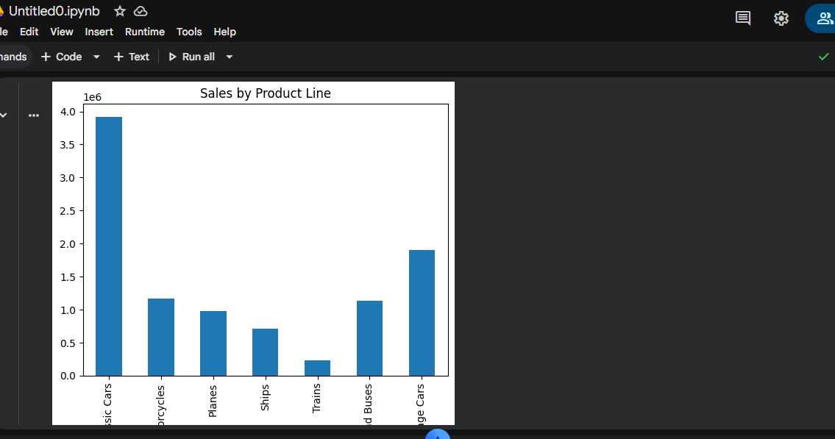

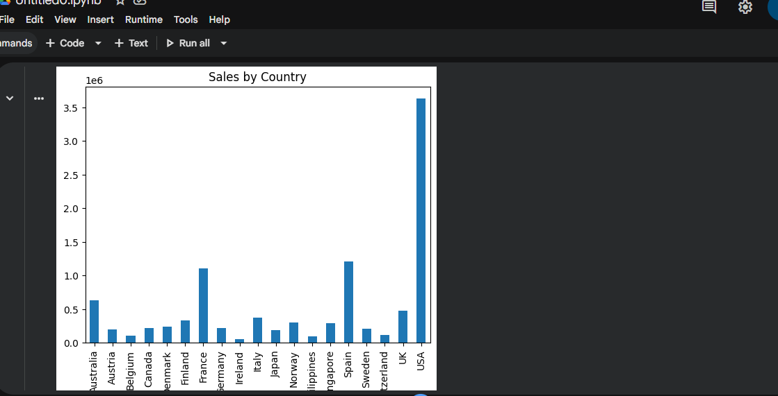

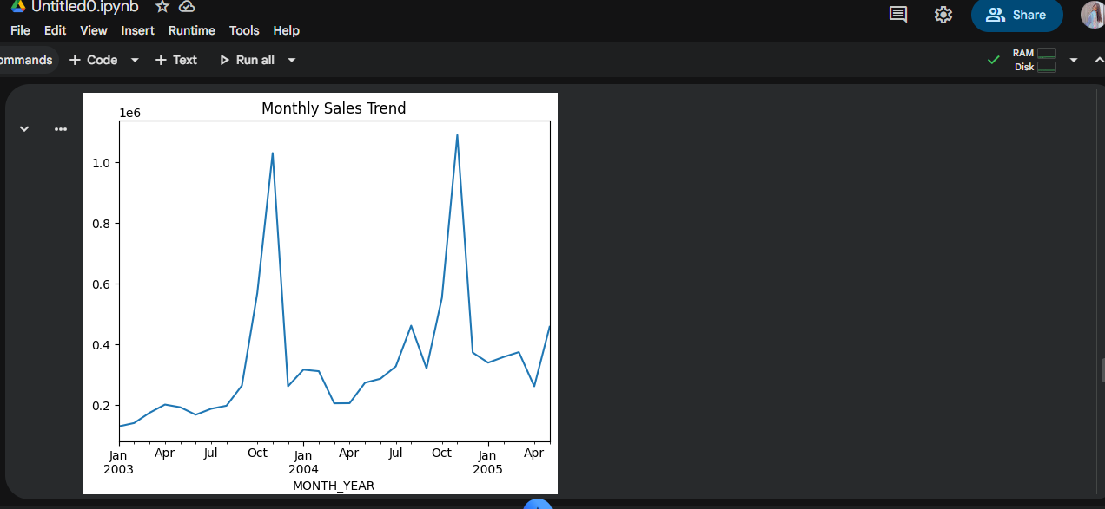

KEY INSIGHTS
- USA is the highest revenue generating country
- Classic Cars is the top-performing product line
- Sales show seasonal variation across months
- Few product lines contribute majority of revenue (Pareto effect)
- Some regions show low sales and need improvement

BUSINESS RECOMMENDATIONS
- Focus marketing efforts on high-performing countries like USA
- Improve sales in low-performing regions using promotions
- Promote top-selling product lines
- Use seasonal trends for better planning
- Improve data collection process for better accuracy
CONCLUSION
The analysis helped identify key sales patterns, top-performing segments, and areas of improvement. These insights can help improve business strategy and revenue growth.

